Sunday 9th Feb 4 p.m.  Racial Justice Service  St Peter’s Church  46 Hyndland St  Partick  G11 5PSBUFFET TO FOLLOW  Professor Reddie a leading scholar in the field of Black Theology; editor of Black Theology  Director of the Oxford Centre for Religion and Culture is the main speaker  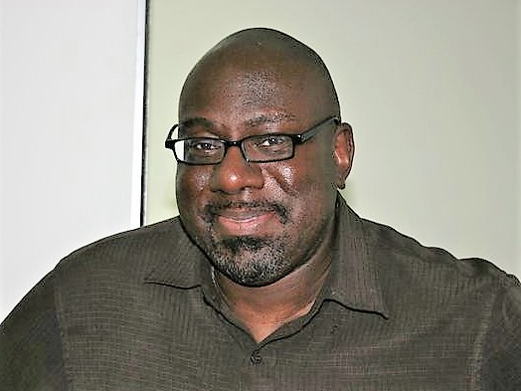  We are delighted to have him as he is he is in demand as a conference speaker (booked for Greenbelt 2020) and is also a trustee of the ‘British and Irish Association for Practical Theology’.  Refreshments to Follow in the Hall | SCOTTISH CHURCHES  ANTI HUMAN TRAFFICKING GROUP  GLASGOW CHURCH LEADERS  WITH  ECUMENICAL RELATIONS AND INTERFAITH MATTERS COMMITTEE PRESBYTERY OF GLASGOW  justice and peace glasgow and scotland  MECTIS  and  Scottish asian christian fellowship

