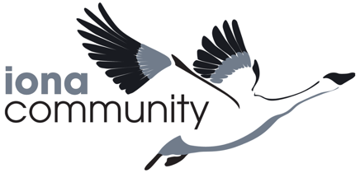
JOURNEYS TO JUSTICE:
RACISM AND RESOLUTION

BOOK NOW

28 May - 3 June 2022
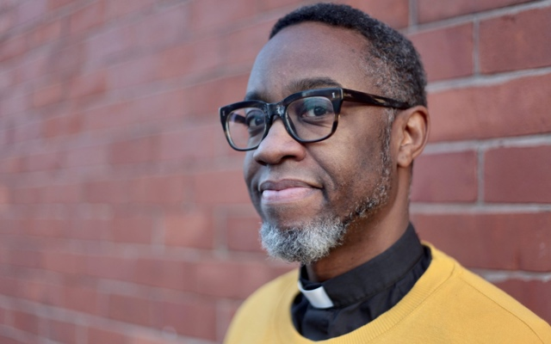
We are running a new programme at Iona Abbey called “Journeys to Justice”. We will examine why black and brown people are still right to be angry, and what steps we can all take to fight the underlying causes of racism.

This will be a week of radical exploration with Azariah France-Williams (right) and Richard Springer as we use scripture, story, and song to deepen our common humanity and to acknowledge our contested histories.

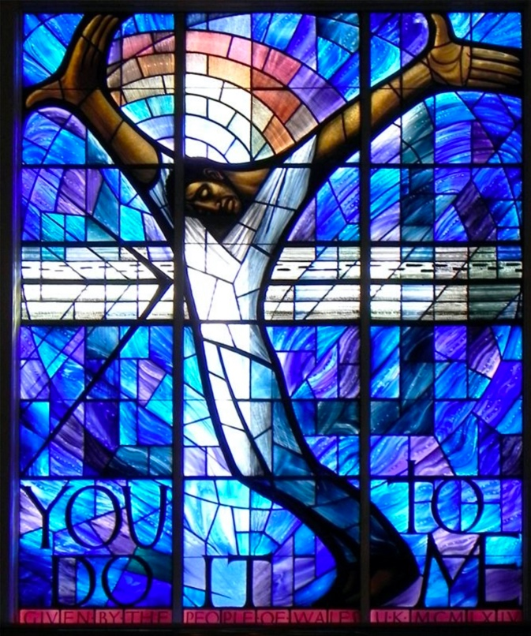

Free Places
We have a number of free places available to cover full board and some travel costs. The course will be most appreciated by people of faith or a sympathy with faith-based ideas. Please contact the Abbey warden@iona.org.uk.

Come to investigate one of the most pressing issues of the age and discover solutions and rare insights on this magnificent remote island centre.

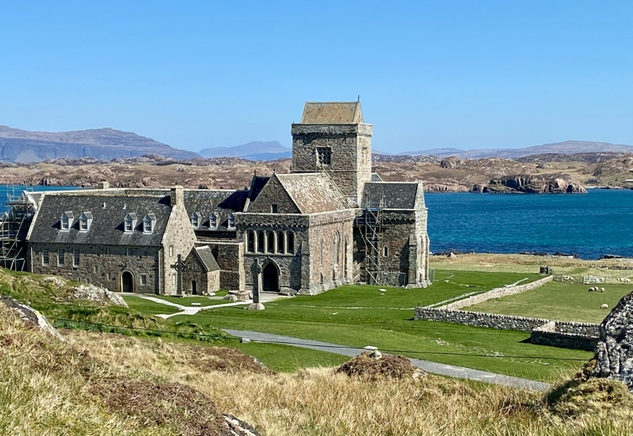
The Iona Community is an ecumenical Christian community which campaigns for social justice and peace.

We run counter cultural courses and activities on the Scottish islands of Mull and Iona, mixing talks and activities against a backdrop of breath-taking scenery.

Through our witness and work, ordinary people are empowered to do extraordinary things in their local communities, through churches and other civic organisations. www.iona.org.uk

