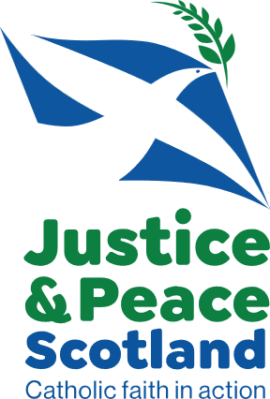

[Your Name]  
[Your Address]

[Your Postcode]

[Your Email]  
[Date]

Dear [MP’s Name],

I am writing to you as one of your constituents and as a supporter of Justice & Peace Scotland. I do so with deep concern at the ongoing war in Gaza and with an urgent plea that the UK government takes stronger action to help end the suffering.

The atrocities unfolding in Gaza cannot be allowed to continue. A United Nations Commission of Inquiry recently concluded that Israeli authorities and Israeli security forces have committed and are continuing to commit acts of genocide against the Palestinians in the Gaza Strip and multiple reputable aid agencies have confirmed that a man-made famine is now present. This is unconscionable. Thousands of civilians are facing starvation, children are dying from preventable disease, hospitals lack fuel and medicines to save lives, and families have been wrought apart amid the devastation. Children are being identified not by their name but by the acronym WCNSF: wounded child, no surviving family.

In light of this, I urge you to press the UK government to:

* Immediately end **all** arm sales to Israel including components for F-35 jets;
* Do everything in your power to achieve a **permanent ceasefire** and take steps to ensure that ceasefire is implemented and upheld;
* Ensure the **unhindered entry of humanitarian aid**: the siege of Gaza must be stopped and food, fuel, and medical supplies must be allowed in;
* Support the **immediate release of Israeli hostages and missing persons**;
* Work for an outcome that secures a **just and lasting peace for both Palestinians and Israelis**, built on dignity, human rights, and international law.

The UK has both the moral duty and the means to act. Simply calling for a ceasefire is not enough: our government must leverage every diplomatic and economic tool at its disposal to ensure that words translate into action. The UK possesses the influence to achieve these objectives and is obligated to uphold international law, including International Humanitarian Law (IHL).

**www.justiceandpeacescotland.org.uk**

**office@justiceandpeacescotland.org.uk**

Justice & Peace Scotland is the operating name of the National Justice and Peace Commission. It is a Commission of the Bishops’ Conference of Scotland.

Catholic National Endowment Trust (also known as The Bishops’ Conference of Scotland) is a charity registered in Scotland. Charity No. SCO 16650

This is particularly pertinent given the ongoing violations of IHL observed throughout the conflict, such as the aforementioned failure to ensure sufficient humanitarian assistance for the population of Gaza and the targeting of aid workers and convoys. These actions contravene the provisional measures ordered by the International Court of Justice (ICJ) in 2024. The UK must lead by example in championing international law and ensuring its consistent application.

Although the UK has suspended *some* export licences to Israel, this partial suspension is far from sufficient. The UK must end all arms licences whenever there is credible evidence that Israel’s conduct in the conflict breaches international humanitarian law. According to Campaign Against the Arms Trade (CAAT) and Oxfam, continued licensing implicates the UK in potential violations, especially given that UK companies provide about 15% of all components for the F-35 fighter jets that are currently used in strikes that have caused widespread civilian death and devastation in Gaza.

As a person of faith, I believe every human life is sacred and that peace, justice, and the protection of the vulnerable should be at the heart of our world as they are at the heart of the Gospel. It is in this spirit that I ask you to stand with those suffering in Gaza today.

I urge you to raise this matter in Parliament and with the government at every opportunity and to advocate for action that can end the bloodshed and prevent further loss of human life.

History will judge how our leaders respond in this moment of crisis. I hope you will use your voice to help bring about an end to this conflict and a future of peace for all across Palestine and Israel.

Yours sincerely,

[Your Name]

**www.justiceandpeacescotland.org.uk**

**office@justiceandpeacescotland.org.uk**

Justice & Peace Scotland is the operating name of the National Justice and Peace Commission. It is a Commission of the Bishops’ Conference of Scotland.

Catholic National Endowment Trust (also known as The Bishops’ Conference of Scotland) is a charity registered in Scotland. Charity No. SCO 16650